RC tutorial 001 EN – Alignment geometry - tangents and curves

====================================================

Revised 2022-10-20

* This tutorial's goal is to teach you how to treat alignments in RailCOMPLETE.
* Assumed RailCOMPLETE skills: None, but basic AutoCAD skills are required.
* Assumed railway skills: You know about railway geometry - lines (tangents) and arcs (curves) in the XY plane.
* Time to spend here: Intermediate: 1 hour
* Suggested reading: “2021-05-23_001 EN Introduction to RailCOMPLETE v2021.0”, which can be downloaded from our web pages.
* Notice to users with non-English versions of AutoCAD – see footnote[1].
* This example was prepared using software release 2022.2.0.7 with Norwegian DNA version “NO-BN 2021.a”,” 2021-11-27T21:11:27+01:00;2021.a”.

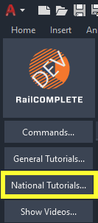 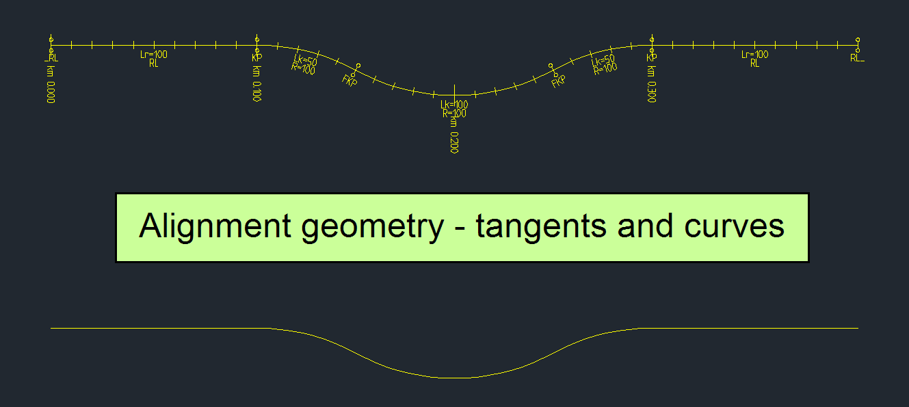

1. Start AutoCAD with RailCOMPLETE, then open the ‘National Tutorials’ folder and locate the DWG file named after this tutorial. You can either type **RC-OpenNationalTutorialsFolder** or you can locate the button below the RC logo in the upper left corner of your AutoCAD window.
2. Locate the lower yellow line. It is called an *alignment*. It is an AutoCAD 2D polyline with an extra embedded RailCOMPLETE data structure inside it. RailCOMPLETE offers many commands to visualize and to modify these embedded data structures.
3. You can also see a similar structure at the top. It is just a regular 2D polyline. It has the same geometrical shape, and it includes a copy of annotations that you are soon going to create yourself. It does not contain embedded RC data - it is just an ordinary entity in AutoCAD.  
     
   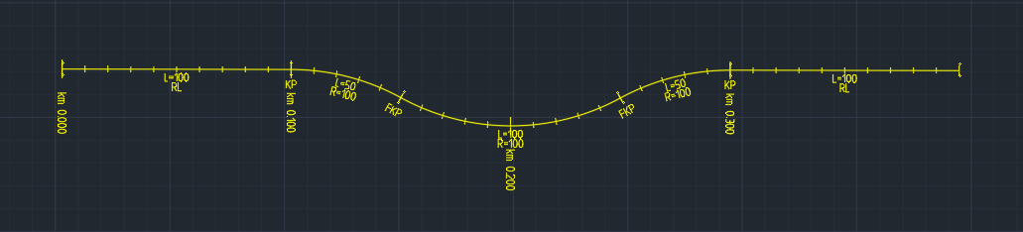
4. Launch the RailCOMPLETE Alignment Manager in any number of ways:   
   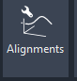

a) By clicking the Alignment Manager button in the ribbon, labeled "Alignments", and featuring a wrench symbol and a 3D graph.

b) By writing 'RC-ManageAlignments' and hitting ENTER.

c) By double-clicking on the logo to the left in the ribbon, this starts the Command Browser, then browse or type in a search pattern 'alignment' and locate the RC-ManageAlignments command, then double-click on the command name.

d) By right-clicking in modelspace (an empty space on AutoCAD screen) and selecting Manage>Alignments...

e) By selecting an alignment, then right-clicking and selecting Manage>Alignments...

1. Adjust the Alignment Manager window size by grabbing the lower right window corner to resize, until you can see the tab buttons "Alignment", "Mileage" and "Reference Alignments".
2. Inside the Alignment Manager window, locate your alignment's name “T1” in the browser field to the left, then click on it and its name turns blue.
3. Locate and activate the "Alignment" tab in the Alignment Manager top row, then activate the "Horizontal" tab on the second row with tabs. You will now see a datagrid displaying the actual details of your alignment.  
   Et bilde som inneholder bord

   Automatisk generert beskrivelse
4. Check "Extended View" to see more details (or use the Alt key after having selected the datagrid). Resize the window if needed.  
   Et bilde som inneholder bord

   Automatisk generert beskrivelse
5. Check "Bind to Selection" in order to synchronize the marked (blue) alignment(s) in Alignment Manager with the currently selected alignments in AutoCAD modelspace.  
   Et bilde som inneholder tekst

   Automatisk generert beskrivelse
6. Check "Invisible" if you want to see alignments residing on layers that are frozen or off.
7. With the alignment T01 in view at the centre of your PC screen, and with the Alignment Manager located off-centre on your PC screen and displaying the \Alignment\Horizontal datagrid, click on the magnifying glass in the lower right corner of the Alignment Manager. This activates the Alignment Manager's Autofocus mode. Try clicking in the datagrid on any row, and see that the graphics in modelspace are highlighted for the alignment segment corresponding to the row you just clicked in. Tangent lines are green, circular arcs are red.  
   
8. Activate the RC-ShowAlignmentName tool (Icon: Alignment with the text 'XYZ') to make the alignment name "[T01]" appear in modelspace as you select the alignment. Adjust the text size using your mouse scrollwheel (or the AutoCAD Zoom Window / Zoom Extents). Note that there is built-in hysteresis in many 'Show' functions, such that text heights etc 'lag behind' somewhat when you zoom IN or zoom OUT.   
    
9. Activate the RC-ShowMileage tool (Icon: Alignment with short transversal lines) to see mileage markers appear along your alignment. As you zoom in and out, note that there is hysteresis in the automatic annotation size adjustment.  
    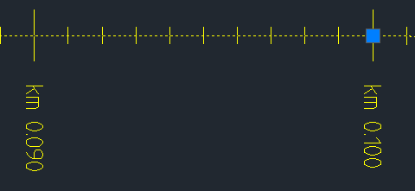
10. Zoom in and out until you're happy with your annotations, then right-click and select 'RailCOMPLETE Annotation => Copy annotations to Drawing' from the context menu to turn these annotations into permanent (passive) drawing elements. You may COPY, MOVE, EXPLODE or ERASE these annotations just as any other AutoCAD drawing element.  
    Et bilde som inneholder tekst

    Automatisk generert beskrivelse
11. Activate the RC-ShowGeometry tool (Icon: Alignment with two 'R's) to see the alignment's horizontal profile details directly in modelspace.  
      
     Et bilde som inneholder tekst, klokke

    Automatisk generert beskrivelse
12. Trying RC-ShowProfile will not display anything - since our first alignment does not contain profile (elevation) data.  
    
13. Try out the annotation tool RC-ShowTwoRails as well (Icon: Two parallel lines with a '2').  
     
14. Click in modelspace, then select the alignment there. Grab one of the small square blue grip points (i.e. the AutoCAD grips for a 2D polyline) and try moving one grip. Note that the datagrid in the Alignment Manager changes correspondingly as you make direct modifications to the alignment in modelspace.  
    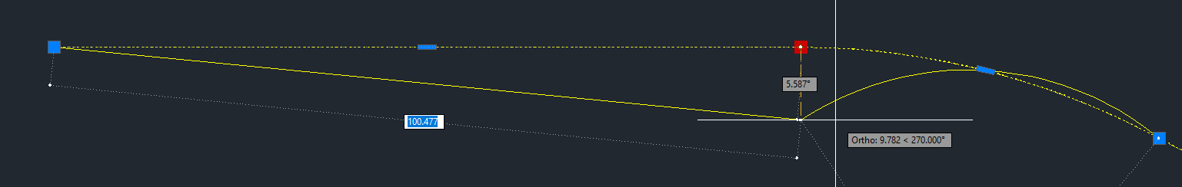  
      
    Et bilde som inneholder bord

    Automatisk generert beskrivelse
15. Try hovering over the elongated grip in the middle of a 2D poyline segment and use AutoCAD to turn a line into an arc ('Convert to Arc') or vice versa ('Convert to Line'). Use "Add Vertex" to insert more vertices or "Delete Vertex" to delete existing ones. Try changing an arc's radius simply by dragging and dropping an arc's grip.  
    Et bilde som inneholder tekst

    Automatisk generert beskrivelse   
      
    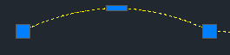  
    Et bilde som inneholder bord

    Automatisk generert beskrivelse
16. Try extending the length of a polyline by simply dragging & dropping a grip point.
17. Try also to use the OSNAP 'nearest' snap setting (press F3 or write OSNAP), move a grip along the polyline, and type in a positive or negative change number. Then the polyline's end point (grip) "jumps" in the direction specified by the number's sign and adds the length that you specified. Note: You can always override the suggested AutoCAD snap method by using Ctrl+RightClick and select another snap method.
18. Play around until you get familiar with AutoCAD polylines this way. RailCOMPLETE picks up whatever you do in AutoCAD and stores the changes in an internal RC alignment format.
19. You may store your new alignment either as an AutoCAD file (SAVEAS, Ctrl+Shift+S) or as a LandXML file using RC-ExportAlignmentsToLandXml - Try it!
20. Turn on the RC-ShowPosition tool and get familiar with the position display text which appears at your CAD cursor whenever you "pick up" an alignment. Note that there is a right angle bracket '>' to the right of the position text when mileage increases towards the right part of your screen, and a left angle bracket '<' to the left of the position text whenever the mileage increases towards the left part of your screen.  
    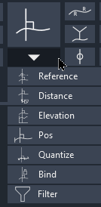 Et bilde som inneholder tekst

    Automatisk generert beskrivelse
21. Try reversing the direction of increasing mileage with RC-ReverseAlignment (which is found under the Edit button). Then try deleting the mileage annotation you produced earlier and insert a new one with this reversed mileage direction.  
    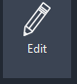  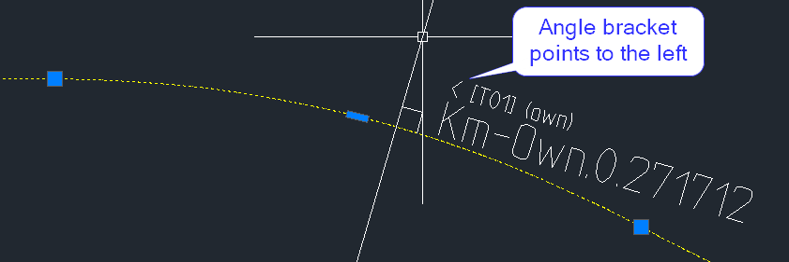
22. Try breaking your alignment using RC-BreakAlignment (under the Edit button). Check with Alignment Manager that you now have got TWO alignments with identical names (but different GUIDs). Note that a track connection object – a ‘continuation’ object – appears:  
      
    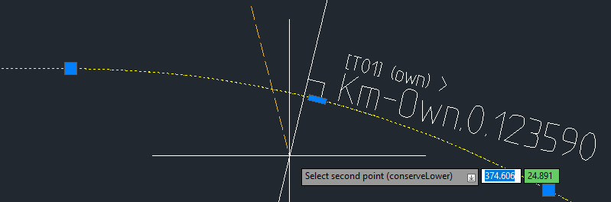 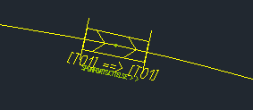
23. Then join the two alignment pieces using RC-JoinAlignments (under the Edit button). What are the differences compared to the original alignment T01? None – and the connection object also disappears.   
     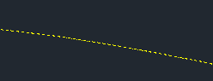  
    Note: When two alignments are joined, then the alignment that you selected first will retain its GUID and properties, and will add the other’s extent to its own extent. The second alignment object is removed.
24. Try moving the whole alignment using the AutoCAD MOVE command. Note that the geometry does not change, but all the Start XY and End XY points in the Alignment Manager \ Alignment \ Horizontal datagrid will change (make sure you have checked the 'Extended View' box).
25. Use COPY or COPYBASE / PASTECLIP to make multiple copies of your alignment. They will all bear the same name (but each one will have a globally unique ID, called a 'GUID'). If you want to copy objects (or any CAD item) between different DWG drawings, then you must use the AutoCAD COPYBASE command (Ctrl+Shift+C). Use **RC-ManageProperties** to see the GUID.  
    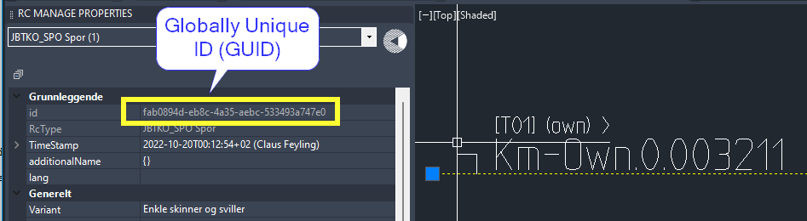  
      
    ** Caution: When using the COPYBASE / Paste commands to move data between two drawings, the XYZ coordinates may mean something else in the destination DWG file. Make sure that you have selected the user coordinate system (UCS) 'World' in both drawings before you copy/paste between them. Relevant AutoCAD commands to check out: UCS, PLAN or EXPLAN, COPYBASE and PASTE.
26. The AutoCAD OFFSET command does NOT create a new RC object, but you may create a new alignment from an existing alignment using the **RC-OffsetAlignment** command.   
       
    Select the items that you want to bring over to the new alignment and press OK, then select side of the source alignment and press ENTER (or click, depending on you AutoCAD settings):  
      
    Et bilde som inneholder tekst

    Automatisk generert beskrivelse  
      
    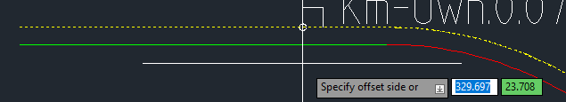
27. SAVE your drawing again (Ctrl+S) or SAVEAS to a new file name (Ctrl+Shift+S).
28. Then try UNDO-ing everything you have done using the AutoCAD UNDO command, or simply press Ctrl+Z repeatedly until there is nothing left to undo, or undo a whole group of historic commands. Use Ctrl+Y or click the right-arrow to “undo the undo”. Check out the F2 log window to see what has been done.  
    Et bilde som inneholder tekst

    Automatisk generert beskrivelse

Please check our website www.railcomplete.com for updates.  
Corrections and suggestions are welcome to [support@railcomplete.com](mailto:support@railcomplete.com).  
Thank you for using RC Tutorials!

1. Your AutoCAD session has probably been started from a Windows shortcut of the type:  
   “C:\Program Files\Autodesk\AutoCAD 2022\acad.exe” /product ACAD /language “fr-FR”, where “fr-FR” means “French language, France’s version”, or similar, or no language specified (English is the native language for AutoCAD). Native AutoCAD commands may have different names in your language pack, other than the COPY, COPYBASE, FIND etc that you see in our tutorial texts. In order to instruct AutoCAD to accept the native English command name, precede the native (English) command name by an underscore character, ‘_’. For instance: ‘_FIND’ will start AutoCAD’s native ‘FIND’ command even if you are using AutoCAD with the French language pack, where the command in French is called ‘RECHERCHER’.If a command needs an argument ‘ON’, and the French menu says ‘Allumer’, then you can enter ‘_ON’ to instruct AutoCAD to use the option’s native name. Furthermore, the English AutoCAD object selection prompt (command _SELECT) accepts many keyboard shortcuts such as A = (add) add to selection set, R = (remove) remove from selection set and AL = (all) all objects (and many more). These shortcuts are named differently in other language packs. In French they are for instance A=ajouter, S=supprimer, TO=tout. Consult AutoCAD Help in your native language.